

SIMATS SCHOOL OF ENGINEERING
SAVEETHA INSTITUTE OF MEDICAL AND TECHNICAL SCIENCES
CHENNAI-602105

ASSESSMENT 1
CSA1006-SOFTWARE ENGINEERING
Problem 2: Feasibility Study for a Smart Parking System
Scenario
A city plans to develop a smart Parking System to help drivers find available parking spaces quickly. The system uses sensors, cameras, and a mobile application to display real-time parking availability. Before developing the system, the company must perform a feasibility study to determine whether the project is practical, affordable, and beneficial.

1. Feasibility Study

a) Technical Feasibility
- Sensors and cameras can detect available parking spaces.
- Mobile application can display parking availability in real time.
- Cloud database can store parking information securely.

b) Economic Feasibility
- Initial installation cost is high.
- Reduces fuel consumption and traffic congestion.
- Saves money through efficient parking management.

c) Operational Feasibility
- Easy for drivers to use through a mobile app.
- Parking staff can monitor parking spaces efficiently.
- Improves customer satisfaction.

d) Schedule Feasibility
- System can be completed within the planned project duration.
- Development, testing, and deployment can be completed on time.

e) Legal Feasibility
- User data must be protected.
- Follow government regulations for data privacy and security.

Example
A shopping mall installs a Smart Parking System. Drivers check available parking spaces through the mobile app before entering the parking area. This reduces waiting time and improves traffic flow.

2. Benefits of the Smart Parking System
- Reduces traffic congestion.
- Saves drivers' time.
- Minimizes fuel consumption.
- Provides real-time parking information.
- Improves parking space utilization.
- Increases customer satisfaction.

3. Possible Challenges
- High installation cost.
- Sensor or camera failure.
- Internet connectivity issues.
- System maintenance costs.
- Data security and privacy risks.

4. Recommended Solutions
- Install high-quality sensors and cameras.
- Perform regular maintenance.
- Secure user data using encryption.
- Provide backup power and internet connection.
- Update the software regularly.
- Train parking staff to manage the system.

BLOCK DIAGRAM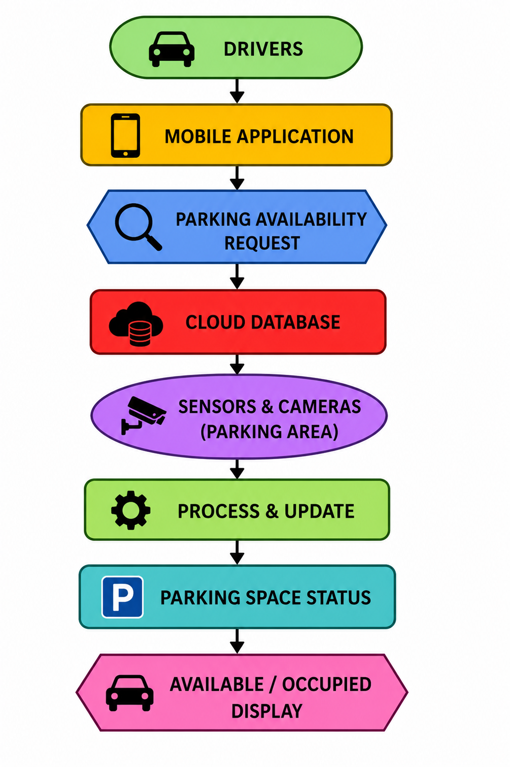

Real-World Example
A shopping mall introduces a Smart Parking System. Sensors detect empty parking spaces and send the information to a cloud server. Drivers use the mobile application to locate available parking spaces before entering the parking area. This reduces congestion, saves time, and improves the overall parking experience.

Conclusion
A Smart Parking System is technically, economically, and operationally feasible. Although the installation cost is high, it provides long-term benefits such as reduced traffic congestion, better parking management, fuel savings, and improved customer satisfaction. With proper planning, maintenance, and security measures, the system can be successfully implemented.

